Concept of Operations for use of Gravity Map
Purpose
To create an app that displays the gravity force for any location on Earth. Grab data about gravity around the world on a gravity map, or geoid, and use positioning data to show gravity at any location. You also could add information about the GOCE mission or other missions, and extend the capabilities to include magnetic field data from the SWARM mission.
Background
The geoid is a smooth but highly irregular surface that corresponds not to the actual surface of the Earth's crust, but to a surface which can only be known through extensive gravitational measurements and calculations. Missions such as GRACE and GOCE have measured gravitation from Space and allow a precise description of the geoid, or in other words: produce a gravity map of Earth. Recently the SWARM mission has been launched to also map the magnetic field around our Earth.
Potential Levels of service to be envisaged (to be discussed):
- Gravity field distribution at any given location on the Earth’s surface
- Gravity variations based on the Moon’s pull of the Earth at a specific date and time (history)
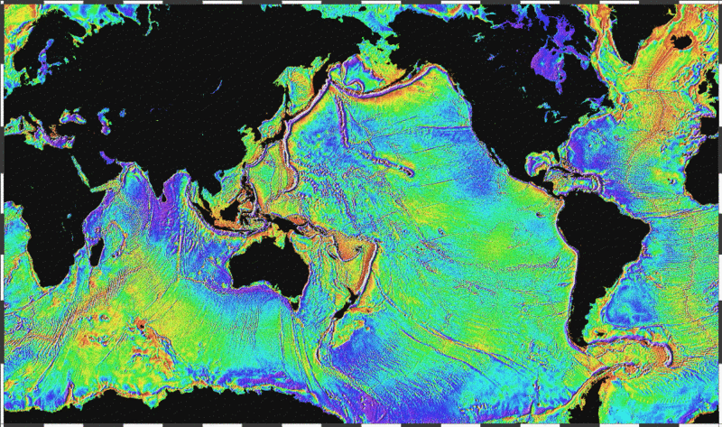
Operational Use of Gravity Map
- Depository to be used by scientists on the go as a reference measurement to show the Earth’s surface as influenced only by gravity (GOCE dataset) (example)
- Shed light on gravity variations over specific locations across time (historical depository)
Identification of Requirements:
- Key functions will be derived from the operational use of this application
- Specs to consider:
  - General Requirements
  - Inbound/Outbound Processing
  - Users Requests (filter selection), Interface Characteristics
  - Map Refreshment based on new data collation
  - Potential Future Enhancements
Discussion of Implementation Issues
Architectural Solution
Design Solution:
- Design Criteria of the Gravity Map - to be based off the System Requirements Specifications
- Detailed System Design
  - Assumptions
  - Hardware Platform application is to be implemented on
  - Gravity Map Software Design Solution, software processes to be developed based of architectural solution, including modules for:
    - Gravity Data Collection – Identification and acquisition of datasets
    - Dataset processing to combine various datasets (if using multiple resources)
    - Dataset processing for visual output to end users
    - Dataset configuration customization
- Testing – Concept Test Phase, Integration Testing of App with Mobile

